**圖表一、輸入層120x120**

|  |  |  |  |  |  |  |  |  |  |
| --- | --- | --- | --- | --- | --- | --- | --- | --- | --- |
|  |  | 第一次 | |  | 第二次 | |  | 第三次 | |
|  |  | **訓練** | **測試** |  | **訓練** | **測試** |  | **訓練** | **測試** |
| Epoch 1/20 |  | **0.3647** | **0.4833** |  | **0.9565** | **0.9106** |  | **0.9788** | **0.9197** |
| Epoch 2/20 |  | **0.4748** | **0.5455** |  | **0.9565** | **0.9000** |  | **0.9818** | **0.9091** |
| Epoch 3/20 |  | **0.5619** | **0.6333** |  | **0.9659** | **0.9061** |  | **0.9799** | **0.9121** |
| Epoch 4/20 |  | **0.6160** | **0.7091** |  | **0.9569** | **0.9091** |  | **0.9822** | **0.9136** |
| Epoch 5/20 |  | **0.6602** | **0.7318** |  | **0.9580** | **0.9045** |  | **0.9830** | **0.9136** |
| Epoch 6/20 |  | **0.7121** | **0.7288** |  | **0.9735** | **0.9106** |  | **0.9837** | **0.9182** |
| Epoch 7/20 |  | **0.7469** | **0.7788** |  | **0.9667** | **0.8985** |  | **0.9875** | **0.9152** |
| Epoch 8/20 |  | **0.7927** | **0.8045** |  | **0.9697** | **0.9167** |  | **0.9799** | **0.9076** |
| Epoch 9/20 |  | **0.8051** | **0.8288** |  | **0.9758** | **0.9091** |  | **0.9845** | **0.9167** |
| Epoch 10/20 |  | **0.8305** | **0.8409** |  | **0.9792** | **0.9136** |  | **0.9841** | **0.9121** |
| Epoch 11/20 |  | **0.8562** | **0.8379** |  | **0.9849** | **0.9152** |  | **0.9883** | **0.9182** |
| Epoch 12/20 |  | **0.8838** | **0.8864** |  | **0.9799** | **0.9121** |  | **0.9856** | **0.9030** |
| Epoch 13/20 |  | **0.9020** | **0.8803** |  | **0.9754** | **0.9212** |  | **0.9841** | **0.9061** |
| Epoch 14/20 |  | **0.9187** | **0.8955** |  | **0.9629** | **0.9152** |  | **0.9773** | **0.9091** |
| Epoch 15/20 |  | **0.9289** | **0.8970** |  | **0.9671** | **0.9136** |  | **0.9849** | **0.9061** |
| Epoch 16/20 |  | **0.9406** | **0.9045** |  | **0.9705** | **0.9197** |  | **0.9807** | **0.9167** |
| Epoch 17/20 |  | **0.9296** | **0.9091** |  | **0.9773** | **0.9030** |  | **0.9792** | **0.9167** |
| Epoch 18/20 |  | **0.9538** | **0.9106** |  | **0.9697** | **0.8924** |  | **0.9898** | **0.9152** |
| Epoch 19/20 |  | **0.9440** | **0.9000** |  | **0.9743** | **0.9091** |  | **0.9864** | **0.9197** |
| Epoch 20/20 |  | **0.9497** | **0.9030** |  | **0.9777** | **0.9227** |  | **0.9815** | **0.9106** |
| AVG. |  | **0.7886** | **0.8005** |  | **0.9699** | **0.9102** |  | **0.9832** | **0.9130** |

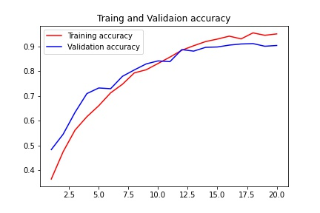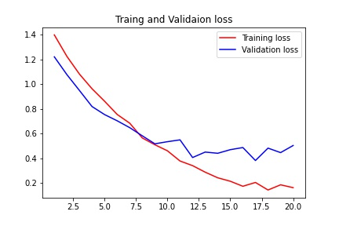

**訓練與測試精準度**

**(輸入層120x120)**

**訓練與測試損耗**

**(輸入層120x120)**

**圖表二、輸入層150x150**

|  |  |  |  |  |  |  |  |  |  |
| --- | --- | --- | --- | --- | --- | --- | --- | --- | --- |
|  |  | 第一次 | |  | 第二次 | |  | 第三次 | |
|  |  | **訓練** | **測試** |  | **訓練** | **測試** |  | **訓練** | **測試** |
| Epoch 1/20 |  | **0.3628** | **0.4909** |  | **0.9330** | **0.8591** |  | **0.9705** | **0.9091** |
| Epoch 2/20 |  | **0.5078** | **0.5636** |  | **0.9361** | **0.9000** |  | **0.9644** | **0.9136** |
| Epoch 3/20 |  | **0.5619** | **0.6227** |  | **0.9463** | **0.9015** |  | **0.9747** | **0.8985** |
| Epoch 4/20 |  | **0.6235** | **0.5818** |  | **0.9425** | **0.9106** |  | **0.9724** | **0.9076** |
| Epoch 5/20 |  | **0.6659** | **0.6864** |  | **0.9467** | **0.9030** |  | **0.9690** | **0.9106** |
| Epoch 6/20 |  | **0.7344** | **0.7394** |  | **0.9508** | **0.9076** |  | **0.9754** | **0.9106** |
| Epoch 7/20 |  | **0.7794** | **0.7318** |  | **0.9519** | **0.8909** |  | **0.9784** | **0.9136** |
| Epoch 8/20 |  | **0.8104** | **0.8091** |  | **0.9417** | **0.9076** |  | **0.9724** | **0.9106** |
| Epoch 9/20 |  | **0.8585** | **0.8242** |  | **0.9531** | **0.9106** |  | **0.9599** | **0.8939** |
| Epoch 10/20 |  | **0.8884** | **0.8636** |  | **0.9595** | **0.9091** |  | **0.9625** | **0.8955** |
| Epoch 11/20 |  | **0.9001** | **0.8409** |  | **0.9659** | **0.9076** |  | **0.9762** | **0.9030** |
| Epoch 12/20 |  | **0.9122** | **0.8773** |  | **0.9595** | **0.9106** |  | **0.9796** | **0.9030** |
| Epoch 13/20 |  | **0.9073** | **0.8909** |  | **0.9603** | **0.9106** |  | **0.9743** | **0.9000** |
| Epoch 14/20 |  | **0.9485** | **0.9000** |  | **0.9671** | **0.9152** |  | **0.9754** | **0.9121** |
| Epoch 15/20 |  | **0.9501** | **0.8985** |  | **0.9512** | **0.8955** |  | **0.9788** | **0.9045** |
| Epoch 16/20 |  | **0.9576** | **0.8985** |  | **0.9622** | **0.9136** |  | **0.9811** | **0.9106** |
| Epoch 17/20 |  | **0.9569** | **0.9076** |  | **0.9622** | **0.9197** |  | **0.9845** | **0.9121** |
| Epoch 18/20 |  | **0.9656** | **0.8955** |  | **0.9712** | **0.9106** |  | **0.9720** | **0.9121** |
| Epoch 19/20 |  | **0.9629** | **0.8909** |  | **0.9671** | **0.9106** |  | **0.9811** | **0.9106** |
| Epoch 20/20 |  | **0.9739** | **0.9045** |  | **0.9678** | **0.9136** |  | **0.9807** | **0.9030** |
| AVG. |  | **0.8114** | **0.7909** |  | **0.9548** | **0.9054** |  | **0.9742** | **0.9067** |

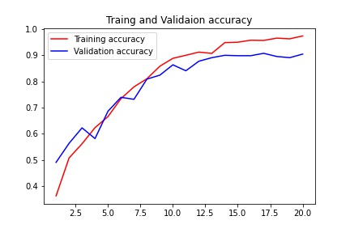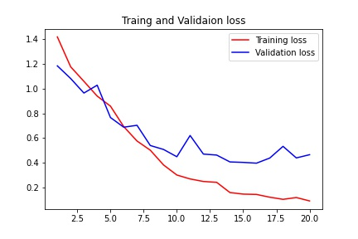

**訓練與測試精準度**

**(輸入層150x150)**

**訓練與測試損耗**

**(輸入層150x150)**

**圖表三、輸入層180x180**

|  |  |  |  |  |  |  |  |  |  |
| --- | --- | --- | --- | --- | --- | --- | --- | --- | --- |
|  |  | 第一次 | |  | 第二次 | |  | 第三次 | |
|  |  | **訓練** | **測試** |  | **訓練** | **測試** |  | **訓練** | **測試** |
| Epoch 1/20 |  | **0.3568** | **0.4818** |  | **0.9330** | **0.8939** |  | **0.9777** | **0.9045** |
| Epoch 2/20 |  | **0.4654** | **0.5485** |  | **0.9629** | **0.8879** |  | **0.9701** | **0.9091** |
| Epoch 3/20 |  | **0.5388** | **0.6091** |  | **0.9648** | **0.8894** |  | **0.9724** | **0.8924** |
| Epoch 4/20 |  | **0.6065** | **0.6833** |  | **0.9538** | **0.8894** |  | **0.9724** | **0.9106** |
| Epoch 5/20 |  | **0.6425** | **0.7106** |  | **0.9489** | **0.8803** |  | **0.9777** | **0.9061** |
| Epoch 6/20 |  | **0.7174** | **0.7500** |  | **0.9557** | **0.8955** |  | **0.9735** | **0.9197** |
| Epoch 7/20 |  | **0.7544** | **0.8030** |  | **0.9580** | **0.8818** |  | **0.9856** | **0.9091** |
| Epoch 8/20 |  | **0.8025** | **0.8136** |  | **0.9557** | **0.9106** |  | **0.9803** | **0.9045** |
| Epoch 9/20 |  | **0.8430** | **0.7894** |  | **0.9629** | **0.8848** |  | **0.9834** | **0.9030** |
| Epoch 10/20 |  | **0.8759** | **0.8727** |  | **0.9659** | **0.8939** |  | **0.9834** | **0.9076** |
| Epoch 11/20 |  | **0.8941** | **0.8530** |  | **0.9671** | **0.8864** |  | **0.9788** | **0.9121** |
| Epoch 12/20 |  | **0.9012** | **0.8530** |  | **0.9599** | **0.9091** |  | **0.9750** | **0.9076** |
| Epoch 13/20 |  | **0.9107** | **0.8515** |  | **0.9709** | **0.9030** |  | **0.9762** | **0.8970** |
| Epoch 14/20 |  | **0.9217** | **0.8742** |  | **0.9728** | **0.910** |  | **0.9781** | **0.8985** |
| Epoch 15/20 |  | **0.9379** | **0.8848** |  | **0.9709** | **0.8985** |  | **0.9720** | **0.9015** |
| Epoch 16/20 |  | **0.9421** | **0.8879** |  | **0.9720** | **0.9030** |  | **0.9777** | **0.9000** |
| Epoch 17/20 |  | **0.9497** | **0.8727** |  | **0.9694** | **0.9076** |  | **0.9728** | **0.9045** |
| Epoch 18/20 |  | **0.9410** | **0.8803** |  | **0.9622** | **0.9045** |  | **0.9792** | **0.8955** |
| Epoch 19/20 |  | **0.9489** | **0.9000** |  | **0.9781** | **0.9061** |  | **0.9807** | **0.9015** |
| Epoch 20/20 |  | **0.9595** | **0.8873** |  | **0.9750** | **0.9076** |  | **0.9765** | **0.9061** |
| AVG. |  | **0.7955** | **0.7903** |  | **0.9630** | **0.8972** |  | **0.9772** | **0.9045** |

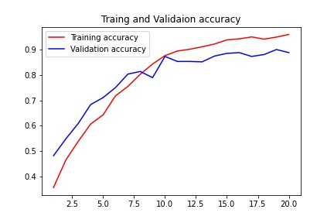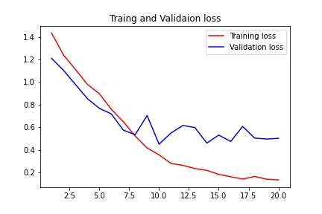

**訓練與測試精準度**

**(輸入層180x180)**

**訓練與測試損耗**

**(輸入層180x180)**

**圖表四、Batch Size**

|  |  |  |  |  |  |  |
| --- | --- | --- | --- | --- | --- | --- |
|  |  | Batch size = 32 | |  | Batch size = 64 | |
|  |  | **訓練** | **測試** |  | **訓練** | **測試** |
| Epoch 1/20 |  | **0.3700** | **0.5197** |  | **0.3383** | **0.4758** |
| Epoch 2/20 |  | **0.4930** | **0.6152** |  | **0.4582** | **0.5697** |
| Epoch 3/20 |  | **0.5793** | **0.6424** |  | **0.5244** | **0.6439** |
| Epoch 4/20 |  | **0.6436** | **0.6667** |  | **0.5638** | **0.6667** |
| Epoch 5/20 |  | **0.6663** | **0.6894** |  | **0.6137** | **0.6924** |
| Epoch 6/20 |  | **0.7007** | **0.7424** |  | **0.6652** | **0.7561** |
| Epoch 7/20 |  | **0.7359** | **0.7652** |  | **0.7136** | **0.7424** |
| Epoch 8/20 |  | **0.7484** | **0.7894** |  | **0.7219** | **0.7742** |
| Epoch 9/20 |  | **0.7927** | **0.8121** |  | **0.7491** | **0.7955** |
| Epoch 10/20 |  | **0.8104** | **0.8379** |  | **0.7877** | **0.8136** |
| Epoch 11/20 |  | **0.8449** | **0.8348** |  | **0.7961** | **0.8333** |
| Epoch 12/20 |  | **0.8540** | **0.8470** |  | **0.8165** | **0.8394** |
| Epoch 13/20 |  | **0.8899** | **0.8606** |  | **0.8464** | **0.8394** |
| Epoch 14/20 |  | **0.9012** | **0.8758** |  | **0.8384** | **0.8485** |
| Epoch 15/20 |  | **0.9130** | **0.8697** |  | **0.8778** | **0.8606** |
| Epoch 16/20 |  | **0.9258** | **0.8606** |  | **0.8801** | **0.8621** |
| Epoch 17/20 |  | **0.9323** | **0.8894** |  | **0.9024** | **0.8773** |
| Epoch 18/20 |  | **0.9425** | **0.8818** |  | **0.9376** | **0.8848** |
| Epoch 19/20 |  | **0.9432** | **0.8939** |  | **0.9247** | **0.8652** |
| Epoch 20/20 |  | **0.9538** | **0.8924** |  | **0.9330** | **0.8758** |
| AVG. |  | **0.7820** | **0.7893** |  | **0.7444** | **0.7758** |

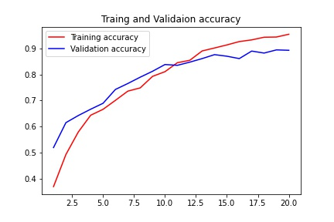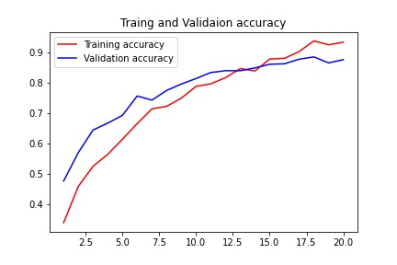

**訓練與測試精準度**

**(batch-size = 64)**

**訓練與測試精準度**

**(batch-size = 32)**

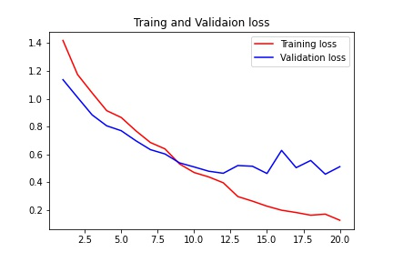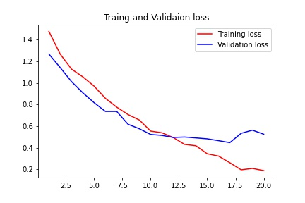

**訓練與測試損耗**

**(batch-size = 64)**

**訓練與測試損耗**

**(batch-size = 32)**

**圖表五、Randonflip()**

|  |  |  |  |  |  |  |  |  |  |
| --- | --- | --- | --- | --- | --- | --- | --- | --- | --- |
|  |  | 第一次 | |  | 第二次 | |  | 第三次 | |
|  |  | **訓練** | **測試** |  | **訓練** | **測試** |  | **訓練** | **測試** |
| Epoch 1/20 |  | **0.3273** | **0.4379** |  | **0.7988** | **0.8182** |  | **0.8861** | **0.8818** |
| Epoch 2/20 |  | **0.4264** | **0.4712** |  | **0.8070** | **0.8364** |  | **0.8994** | **0.8788** |
| Epoch 3/20 |  | **0.4589** | **0.4970** |  | **0.8180** | **0.8061** |  | **0.8944** | **0.8833** |
| Epoch 4/20 |  | **0.5112** | **0.5591** |  | **0.8089** | **0.8242** |  | **0.8994** | **0.8970** |
| Epoch 5/20 |  | **0.5664** | **0.6379** |  | **0.8214** | **0.8182** |  | **0.9035** | **0.8970** |
| Epoch 6/20 |  | **0.5891** | **0.6545** |  | **0.8316** | **0.8121** |  | **0.9168** | **0.8591** |
| Epoch 7/20 |  | **0.6190** | **0.6970** |  | **0.8271** | **0.8273** |  | **0.9179** | **0.8879** |
| Epoch 8/20 |  | **0.6470** | **0.7076** |  | **0.8392** | **0.8394** |  | **0.9240** | **0.9076** |
| Epoch 9/20 |  | **0.6810** | **0.6803** |  | **0.8453** | **0.8667** |  | **0.9156** | **0.8606** |
| Epoch 10/20 |  | **0.6833** | **0.7106** |  | **0.8524** | **0.8682** |  | **0.9130** | **0.9000** |
| Epoch 11/20 |  | **0.6792** | **0.7121** |  | **0.8517** | **0.8848** |  | **0.9217** | **0.9106** |
| Epoch 12/20 |  | **0.7087** | **0.7348** |  | **0.8509** | **0.8485** |  | **0.9202** | **0.8818** |
| Epoch 13/20 |  | **0.7106** | **0.7803** |  | **0.8702** | **0.8773** |  | **0.9251** | **0.8879** |
| Epoch 14/20 |  | **0.7321** | **0.7348** |  | **0.8774** | **0.8682** |  | **0.9258** | **0.8697** |
| Epoch 15/20 |  | **0.7340** | **0.7273** |  | **0.8683** | **0.8864** |  | **0.9300** | **0.8833** |
| Epoch 16/20 |  | **0.7507** | **0.7773** |  | **0.8740** | **0.8848** |  | **0.9357** | **0.8970** |
| Epoch 17/20 |  | **0.7499** | **0.7939** |  | **0.8680** | **0.8833** |  | **0.9262** | **0.8818** |
| Epoch 18/20 |  | **0.7560** | **0.8015** |  | **0.8910** | **0.8848** |  | **0.9209** | **0.9197** |
| Epoch 19/20 |  | **0.7749** | **0.8015** |  | **0.8895** | **0.8864** |  | **0.9391** | **0.8909** |
| Epoch 20/20 |  | **0.7995** | **0.8303** |  | **0.8952** | **0.8682** |  | **0.9224** | **0.8970** |
| AVG. |  | **0.6453** | **0.6873** |  | **0.8493** | **0.8545** |  | **0.9169** | **0.8886** |

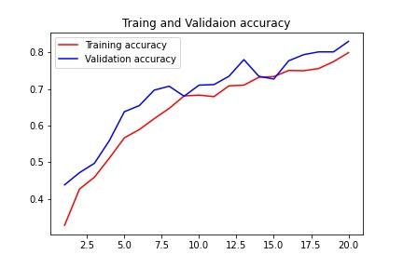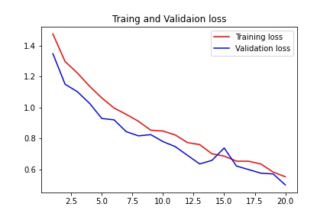

**訓練與測試精準度**

**(randonflip)**

**訓練與測試損耗**

**(randonflip)**

**圖表六、RandonRotation()**

|  |  |  |  |  |  |  |  |  |  |
| --- | --- | --- | --- | --- | --- | --- | --- | --- | --- |
|  |  | 0.1 | |  | 0.2 | |  | 0.3 | |
|  |  | **訓練** | **測試** |  | **訓練** | **測試** |  | **訓練** | **測試** |
| Epoch 1/20 |  | **0.3227** | **0.4697** |  | **0.3235** | **0.4530** |  | **0.3235** | **0.4061** |
| Epoch 2/20 |  | **0.4434** | **0.5879** |  | **0.4495** | **0.5152** |  | **0.3980** | **0.5136** |
| Epoch 3/20 |  | **0.5293** | **0.6455** |  | **0.4911** | **0.6045** |  | **0.4760** | **0.5697** |
| Epoch 4/20 |  | **0.5793** | **0.6773** |  | **0.5414** | **0.6515** |  | **0.5293** | **0.6515** |
| Epoch 5/20 |  | **0.6254** | **0.6758** |  | **0.6084** | **0.6879** |  | **0.5668** | **0.6333** |
| Epoch 6/20 |  | **0.6398** | **0.7167** |  | **0.6311** | **0.6924** |  | **0.6145** | **0.6727** |
| Epoch 7/20 |  | **0.6742** | **0.7258** |  | **0.6470** | **0.7061** |  | **0.6167** | **0.6742** |
| Epoch 8/20 |  | **0.6792** | **0.7136** |  | **0.6723** | **0.7227** |  | **0.6421** | **0.6833** |
| Epoch 9/20 |  | **0.7053** | **0.7561** |  | **0.6826** | **0.6985** |  | **0.6553** | **0.6985** |
| Epoch 10/20 |  | **0.7166** | **0.7424** |  | **0.6928** | **0.7197** |  | **0.6708** | **0.6909** |
| Epoch 11/20 |  | **0.7219** | **0.7212** |  | **0.6720** | **0.7136** |  | **0.6875** | **0.7121** |
| Epoch 12/20 |  | **0.7378** | **0.7682** |  | **0.7053** | **0.7379** |  | **0.6909** | **0.7061** |
| Epoch 13/20 |  | **0.7526** | **0.7591** |  | **0.7106** | **0.7227** |  | **0.7075** | **0.7091** |
| Epoch 14/20 |  | **0.7450** | **0.7803** |  | **0.7272** | **0.7591** |  | **0.7117** | **0.7091** |
| Epoch 15/20 |  | **0.7499** | **0.7848** |  | **0.7268** | **0.7379** |  | **0.7060** | **0.7076** |
| Epoch 16/20 |  | **0.7715** | **0.7803** |  | **0.7325** | **0.7561** |  | **0.7090** | **0.7197** |
| Epoch 17/20 |  | **0.7768** | **0.8121** |  | **0.7423** | **0.7394** |  | **0.7200** | **0.7227** |
| Epoch 18/20 |  | **0.7855** | **0.8167** |  | **0.7416** | **0.7333** |  | **0.7264** | **0.7500** |
| Epoch 19/20 |  | **0.7995** | **0.7894** |  | **0.7567** | **0.6939** |  | **0.7223** | **0.7288** |
| Epoch 20/20 |  | **0.8135** | **0.7924** |  | **0.7420** | **0.7515** |  | **0.7344** | **0.7333** |
| AVG. |  | **0.6785** | **0.7258** |  | **0.6498** | **0.6898** |  | **0.6304** | **0.6696** |

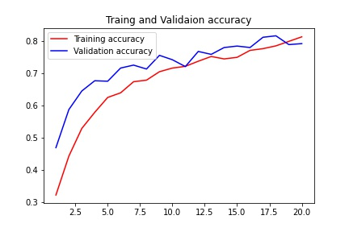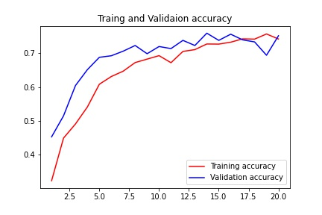

**訓練與測試精準度**

**(RandonRotation(0.2))**

**訓練與測試精準度**

**(RandonRotation(0.1))**

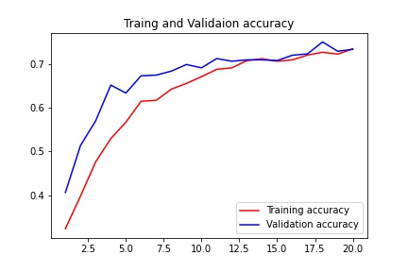

**訓練與測試精準度**

**(RandonRotation(0.3))**

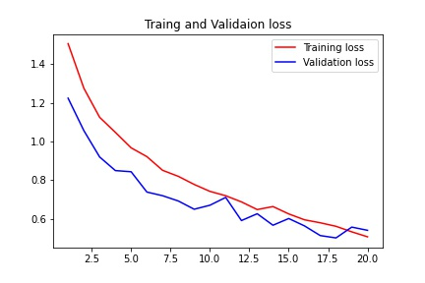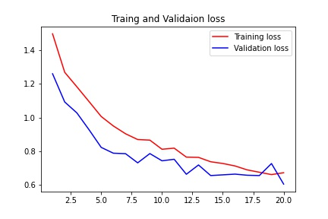

**訓練與測試損耗**

**(RandonRotation(0.2))**

**訓練與測試損耗**

**(RandonRotation(0.1))**

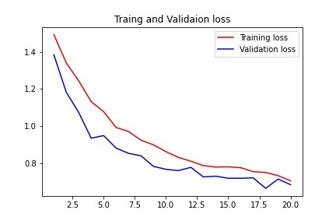

**訓練與測試損耗**

**(RandonRotation(0.3))**

**圖表七、RandonRotation(0.1)**

|  |  |  |  |  |  |  |  |  |  |
| --- | --- | --- | --- | --- | --- | --- | --- | --- | --- |
|  |  | 第一次 | |  | 第二次 | |  | 第三次 | |
|  |  | **訓練** | **測試** |  | **訓練** | **測試** |  | **訓練** | **測試** |
| Epoch 1/20 |  | **0.3227** | **0.4697** |  | **0.7889** | **0.7667** |  | **0.8801** | **0.8788** |
| Epoch 2/20 |  | **0.4434** | **0.5879** |  | **0.7942** | **0.8197** |  | **0.8816** | **0.8682** |
| Epoch 3/20 |  | **0.5293** | **0.6455** |  | **0.8150** | **0.8197** |  | **0.8801** | **0.8682** |
| Epoch 4/20 |  | **0.5793** | **0.6773** |  | **0.8089** | **0.8061** |  | **0.8857** | **0.8712** |
| Epoch 5/20 |  | **0.6254** | **0.6758** |  | **0.8169** | **0.8409** |  | **0.8952** | **0.8485** |
| Epoch 6/20 |  | **0.6398** | **0.7167** |  | **0.8142** | **0.8030** |  | **0.8714** | **0.8379** |
| Epoch 7/20 |  | **0.6742** | **0.7258** |  | **0.8120** | **0.8303** |  | **0.8785** | **0.8667** |
| Epoch 8/20 |  | **0.6792** | **0.7136** |  | **0.8358** | **0.8273** |  | **0.8785** | **0.8485** |
| Epoch 9/20 |  | **0.7053** | **0.7561** |  | **0.8464** | **0.8061** |  | **0.8884** | **0.8697** |
| Epoch 10/20 |  | **0.7166** | **0.7424** |  | **0.8411** | **0.8409** |  | **0.9031** | **0.9000** |
| Epoch 11/20 |  | **0.7219** | **0.7212** |  | **0.8589** | **0.8348** |  | **0.8888** | **0.8636** |
| Epoch 12/20 |  | **0.7378** | **0.7682** |  | **0.8536** | **0.8636** |  | **0.8861** | **0.8909** |
| Epoch 13/20 |  | **0.7526** | **0.7591** |  | **0.8513** | **0.8394** |  | **0.9024** | **0.8803** |
| Epoch 14/20 |  | **0.7450** | **0.7803** |  | **0.8392** | **0.8394** |  | **0.9005** | **0.8818** |
| Epoch 15/20 |  | **0.7499** | **0.7848** |  | **0.8570** | **0.8242** |  | **0.8903** | **0.8758** |
| Epoch 16/20 |  | **0.7715** | **0.7803** |  | **0.8581** | **0.8439** |  | **0.9016** | **0.8985** |
| Epoch 17/20 |  | **0.7768** | **0.8121** |  | **0.8619** | **0.8470** |  | **0.9126** | **0.8955** |
| Epoch 18/20 |  | **0.7855** | **0.8167** |  | **0.8664** | **0.8561** |  | **0.9156** | **0.8803** |
| Epoch 19/20 |  | **0.7995** | **0.7894** |  | **0.8710** | **0.8606** |  | **0.9111** | **0.8712** |
| Epoch 20/20 |  | **0.8135** | **0.7924** |  | **0.8721** | **0.8606** |  | **0.9156** | **0.8924** |
| AVG. |  | **0.6785** | **0.7258** |  | **0.8381** | **0.8315** |  | **0.8934** | **0.8744** |



**訓練與測試精準度**

**(RandonRotation)**

**訓練與測試損耗**

**(RandonRotation)**

**圖表八、Epoch**

|  |  |  |  |  |  |  |  |  |  |
| --- | --- | --- | --- | --- | --- | --- | --- | --- | --- |
|  |  | Epoch = 10 | |  | Epoch = 20 | |  | Epoch =30 | |
|  |  | **訓練** | **測試** |  | **訓練** | **測試** |  | **訓練** | **測試** |
| Epoch 1 |  | **0.3681** | **0.4545** |  | **0.3314** | **0.4712** |  | **0.3330** | **0.4500** |
| Epoch 2 |  | **0.4521** | **0.5773** |  | **0.4650** | **0.5182** |  | **0.4257** | **0.5091** |
| Epoch 3 |  | **0.5062** | **0.6197** |  | **0.5081** | **0.5894** |  | **0.4941** | **0.5455** |
| Epoch 4 |  | **0.5876** | **0.6727** |  | **0.5785** | **0.6439** |  | **0.5789** | **0.6606** |
| Epoch 5 |  | **0.6228** | **0.7167** |  | **0.6235** | **0.6667** |  | **0.6349** | **0.7045** |
| Epoch 6 |  | **0.6682** | **0.7167** |  | **0.6818** | **0.7273** |  | **0.6841** | **0.7470** |
| Epoch 7 |  | **0.6829** | **0.7167** |  | **0.7189** | **0.7318** |  | **0.7314** | **0.7515** |
| Epoch 8 |  | **0.7193** | **0.7667** |  | **0.7465** | **0.7470** |  | **0.7692** | **0.7742** |
| Epoch 9 |  | **0.7529** | **0.7985** |  | **0.7688** | **0.7879** |  | **0.8002** | **0.8091** |
| Epoch 10 |  | **0.7771** | **0.8076** |  | **0.7881** | **0.8182** |  | **0.8218** | **0.8273** |
| Epoch 11 |  | **-** | **-** |  | **0.8396** | **0.8530** |  | **0.8657** | **0.8409** |
| Epoch 12 |  | **-** | **-** |  | **0.8589** | **0.8470** |  | **0.8763** | **0.8667** |
| Epoch 13 |  | **-** | **-** |  | **0.8664** | **0.8545** |  | **0.8748** | **0.8485** |
| Epoch 14 |  | **-** | **-** |  | **0.8997** | **0.8909** |  | **0.8903** | **0.8712** |
| Epoch 15 |  | **-** | **-** |  | **0.9016** | **0.8970** |  | **0.9187** | **0.8667** |
| Epoch 16 |  | **-** | **-** |  | **0.9024** | **0.9091** |  | **0.9168** | **0.8833** |
| Epoch 17 |  | **-** | **-** |  | **0.9262** | **0.8848** |  | **0.9345** | **0.8727** |
| Epoch 18 |  | **-** | **-** |  | **0.9353** | **0.8848** |  | **0.9429** | **0.8894** |
| Epoch 19 |  | **-** | **-** |  | **0.9327** | **0.8727** |  | **0.9425** | **0.8621** |
| Epoch 20 |  | **-** | **-** |  | **0.9410** | **0.8924** |  | **0.9414** | **0.8758** |
| Epoch 21 |  | **-** | **-** |  | **-** | **-** |  | **0.9493** | **0.8773** |
| Epoch 22 |  | **-** | **-** |  | **-** | **-** |  | **0.9542** | **0.8864** |
| Epoch 23 |  | **-** | **-** |  | **-** | **-** |  | **0.9538** | **0.9045** |
| Epoch 24 |  | **-** | **-** |  | **-** | **-** |  | **0.9501** | **0.8909** |
| Epoch 25 |  | **-** | **-** |  | **-** | **-** |  | **0.9576** | **0.8955** |
| Epoch 26 |  | **-** | **-** |  | **-** | **-** |  | **0.9614** | **0.8985** |
| Epoch 27 |  | **-** | **-** |  | **-** | **-** |  | **0.9656** | **0.9015** |
| Epoch 28 |  | **-** | **-** |  | **-** | **-** |  | **0.9690** | **0.9076** |
| Epoch 29 |  | **-** | **-** |  | **-** | **-** |  | **0.9652** | **0.8924** |
| Epoch 30 |  | **-** | **-** |  | **-** | **-** |  | **0.9712** | **0.9076** |
| AVG. |  | **0.6137** | **0.6847** |  | **0.7607** | **0.7744** |  | **0.8325** | **0.8139** |
| PRED, |  | **83.74%** | |  | **97.69%** | |  | **99.51%** | |

**圖表八、Epoch**

|  |  |  |  |  |  |  |
| --- | --- | --- | --- | --- | --- | --- |
|  |  | Epoch = 40 | | | | |
|  |  | **訓練** | **測試** |  | **訓練** | **測試** | |
| Epoch 1 |  | **0.3062** | **0.4848** | **Epoch 21** | **0.9330** | **0.8924** | |
| Epoch 2 |  | **0.4805** | **0.5909** | **Epoch 22** | **0.9473** | **0.9045** | |
| Epoch 3 |  | **0.5432** | **0.6258** | **Epoch 23** | **0.9556** | **0.8909** | |
| Epoch 4 |  | **0.6159** | **0.6576** | **Epoch 24** | **0.9420** | **0.9091** | |
| Epoch 5 |  | **0.6551** | **0.7167** | **Epoch 25** | **0.9516** | **0.8924** | |
| Epoch 6 |  | **0.7022** | **0.7485** | **Epoch 26** | **0.9691** | **0.9030** | |
| Epoch 7 |  | **0.7265** | **0.7788** | **Epoch 27** | **0.9659** | **0.9030** | |
| Epoch 8 |  | **0.7644** | **0.7955** | **Epoch 28** | **0.9575** | **0.9061** | |
| Epoch 9 |  | **0.7821** | **0.8318** | **Epoch 29** | **0.9741** | **0.8773** | |
| Epoch 10 |  | **0.8065** | **0.8000** | **Epoch 30** | **0.9629** | **0.9061** | |
| Epoch 11 |  | **0.8282** | **0.7864** | **Epoch 31** | **0.9654** | **0.9000** | |
| Epoch 12 |  | **0.8550** | **0.8439** | **Epoch 32** | **0.9659** | **0.9076** | |
| Epoch 13 |  | **0.8644** | **0.8652** | **Epoch 33** | **0.9793** | **0.9136** | |
| Epoch 14 |  | **0.8805** | **0.8652** | **Epoch 34** | **0.9749** | **0.8970** | |
| Epoch 15 |  | **0.9090** | **0.8682** | **Epoch 35** | **0.9537** | **0.9091** | |
| Epoch 16 |  | **0.8946** | **0.8848** | **Epoch 36** | **0.9790** | **0.9091** | |
| Epoch 17 |  | **0.9164** | **0.8712** | **Epoch 37** | **0.9786** | **0.9015** | |
| Epoch 18 |  | **0.9207** | **0.8864** | **Epoch 38** | **0.9793** | **0.9015** | |
| Epoch 19 |  | **0.9322** | **0.8985** | **Epoch 39** | **0.9678** | **0.9030** | |
| Epoch 20 |  | **0.9473** | **0.8894** | **Epoch 40** | **0.9793** | **0.9121** | |
|  |  |  |  | **AVG.** | **0.8653** | **0.8432** | |
|  |  |  |  | **PRED.** | **100%** | | |

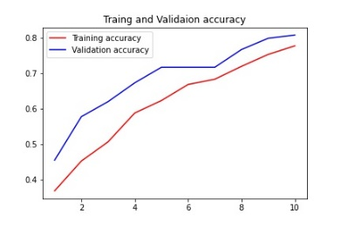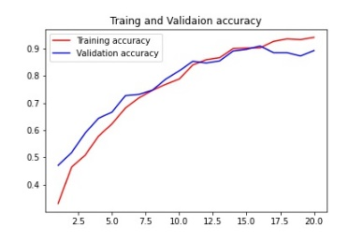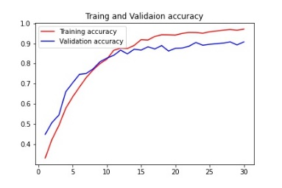

**訓練與測試精準度**

**(epoch=10,20,30,40)**

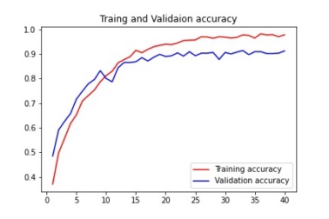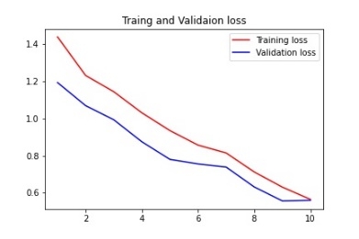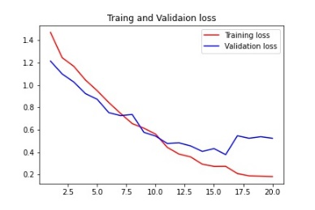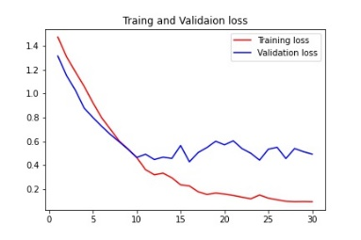

**訓練與測試損耗**

**(epoch=10,20,30,40)**

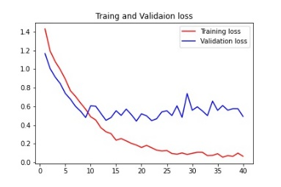

**圖表九、Grey-Epoch**

|  |  |  |  |  |  |  |
| --- | --- | --- | --- | --- | --- | --- |
|  |  | Epoch = 15 | |  | Epoch = 30 | |
|  |  | **訓練** | **測試** |  | **訓練** | **測試** |
| Epoch 1 |  | **0.2256** | **0.2455** |  | **0.2350** | **0.3000** |
| Epoch 2 |  | **0.2623** | **0.3000** |  | **0.3126** | **0.3727** |
| Epoch 3 |  | **0.3147** | **0.3545** |  | **0.3612** | **0.4470** |
| Epoch 4 |  | **0.3631** | **0.4424** |  | **0.4097** | **0.4939** |
| Epoch 5 |  | **0.4108** | **0.4621** |  | **0.4731** | **0.4439** |
| Epoch 6 |  | **0.4482** | **0.5318** |  | **0.4718** | **0.4924** |
| Epoch 7 |  | **0.4785** | **0.5636** |  | **0.5362** | **0.5924** |
| Epoch 8 |  | **0.5315** | **0.6167** |  | **0.5691** | **0.4985** |
| Epoch 9 |  | **0.5639** | **0.6500** |  | **0.5925** | **0.6136** |
| Epoch 10 |  | **0.6105** | **0.6652** |  | **0.6594** | **0.5955** |
| Epoch 11 |  | **0.6383** | **0.7045** |  | **0.6747** | **0.7500** |
| Epoch 12 |  | **0.6605** | **0.7379** |  | **0.7209** | **0.7409** |
| Epoch 13 |  | **0.6988** | **0.7485** |  | **0.7288** | **0.7394** |
| Epoch 14 |  | **0.7069** | **0.7652** |  | **0.7747** | **0.7909** |
| Epoch 15 |  | **0.7252** | **0.7621** |  | **0.7835** | **0.8106** |
| Epoch 16 |  | **-** | **-** |  | **0.8039** | **0.8273** |
| Epoch 17 |  | **-** | **-** |  | **0.8302** | **0.8424** |
| Epoch 18 |  | **-** | **-** |  | **0.8655** | **0.8303** |
| Epoch 19 |  | **-** | **-** |  | **0.8608** | **0.8318** |
| Epoch 20 |  | **-** | **-** |  | **0.8732** | **0.8652** |
| Epoch 21 |  | **-** | **-** |  | **0.8707** | **0.8545** |
| Epoch 22 |  | **-** | **-** |  | **0.8792** | **0.8515** |
| Epoch 23 |  | **-** | **-** |  | **0.8938** | **0.8561** |
| Epoch 24 |  | **-** | **-** |  | **0.9054** | **0.8591** |
| Epoch 25 |  | **-** | **-** |  | **0.9108** | **0.8394** |
| Epoch 26 |  | **-** | **-** |  | **0.9130** | **0.8667** |
| Epoch 27 |  | **-** | **-** |  | **0.9027** | **0.8500** |
| Epoch 28 |  | **-** | **-** |  | **0.9172** | **0.8636** |
| Epoch 29 |  | **-** | **-** |  | **0.9295** | **0.8561** |
| Epoch 30 |  | **-** | **-** |  | **0.9191** | **0.8773** |
| AVG. |  | **0.2546** | **0.285** |  | **0.7193** | **0.7151** |
| PRED, |  | **89.72%** | |  | **97.22%** | |

**圖表十、Grey**

|  |  |  |  |  |  |  |  |  |  |
| --- | --- | --- | --- | --- | --- | --- | --- | --- | --- |
|  |  | 第一次 | |  | 第二次 | |  | 第三次 | |
|  |  | **訓練** | **測試** |  | **訓練** | **測試** |  | **訓練** | **測試** |
| Epoch 1 |  | **0.2191** | **0.2773** |  | **0.2367** | **0.3030** |  | **0.2339** | **0.2424** |
| Epoch 2 |  | **0.2449** | **0.3273** |  | **0.2802** | **0.3303** |  | **0.2499** | **0.3076** |
| Epoch 3 |  | **0.3224** | **0.3136** |  | **0.3369** | **0.3879** |  | **0.3197** | **0.3879** |
| Epoch 4 |  | **0.3585** | **0.3985** |  | **0.3553** | **0.4394** |  | **0.3773** | **0.4606** |
| Epoch 5 |  | **0.3855** | **0.4697** |  | **0.4462** | **0.4970** |  | **0.4088** | **0.4530** |
| Epoch 6 |  | **0.4278** | **0.4697** |  | **0.4672** | **0.5167** |  | **0.4438** | **0.5242** |
| Epoch 7 |  | **0.4807** | **0.4742** |  | **0.5273** | **0.5455** |  | **0.4867** | **0.5455** |
| Epoch 8 |  | **0.5094** | **0.5652** |  | **0.5522** | **0.5712** |  | **0.5415** | **0.6136** |
| Epoch 9 |  | **0.5407** | **0.5955** |  | **0.5930** | **0.6045** |  | **0.5944** | **0.5727** |
| Epoch 10 |  | **0.6111** | **0.6970** |  | **0.6319** | **0.6606** |  | **0.6137** | **0.6318** |
| Epoch 11 |  | **0.6333** | **0.6530** |  | **0.6724** | **0.6485** |  | **0.6630** | **0.7273** |
| Epoch 12 |  | **0.6758** | **0.6879** |  | **0.6889** | **0.6879** |  | **0.6849** | **0.7258** |
| Epoch 13 |  | **0.6947** | **0.7636** |  | **0.7140** | **0.7273** |  | **0.7376** | **0.7621** |
| Epoch 14 |  | **0.7186** | **0.7788** |  | **0.7439** | **0.7636** |  | **0.7592** | **0.7439** |
| Epoch 15 |  | **0.7410** | **0.7667** |  | **0.7649** | **0.7530** |  | **0.7948** | **0.7955** |
| Epoch 16 |  | **0.7665** | **0.8030** |  | **0.7811** | **0.7833** |  | **0.7954** | **0.7939** |
| Epoch 17 |  | **0.7998** | **0.8076** |  | **0.8035** | **0.7970** |  | **0.8298** | **0.8227** |
| Epoch 18 |  | **0.8205** | **0.8197** |  | **0.7971** | **0.8015** |  | **0.8593** | **0.8212** |
| Epoch 19 |  | **0.8316** | **0.8470** |  | **0.8094** | **0.7985** |  | **0.8609** | **0.8242** |
| Epoch 20 |  | **0.8438** | **0.8288** |  | **0.8281** | **0.7864** |  | **0.8896** | **0.8303** |
| Epoch 21 |  | **0.8664** | **0.8470** |  | **0.8235** | **0.7848** |  | **0.8968** | **0.8030** |
| Epoch 22 |  | **0.8784** | **0.8682** |  | **0.8224** | **0.8212** |  | **0.8936** | **0.8364** |
| Epoch 23 |  | **0.8908** | **0.8712** |  | **0.8700** | **0.8212** |  | **0.9026** | **0.8470** |
| Epoch 24 |  | **0.8973** | **0.8697** |  | **0.8719** | **0.8106** |  | **0.9169** | **0.8439** |
| Epoch 25 |  | **0.8986** | **0.8682** |  | **0.8691** | **0.7985** |  | **0.8975** | **0.8455** |
| Epoch 26 |  | **0.9024** | **0.8652** |  | **0.8634** | **0.8242** |  | **0.9035** | **0.8636** |
| Epoch 27 |  | **0.9208** | **0.8500** |  | **0.8791** | **0.8182** |  | **0.9260** | **0.8530** |
| Epoch 28 |  | **0.9215** | **0.8576** |  | **0.8886** | **0.8288** |  | **0.9250** | **0.8485** |
| Epoch 29 |  | **0.9147** | **0.8621** |  | **0.8911** | **0.8303** |  | **0.9297** | **0.8636** |
| Epoch 30 |  | **0.9032** | **0.8515** |  | **0.8970** | **0.8273** |  | **0.9405** | **0.8591** |
| AVG. |  | **0.6873** | **0.698** |  | **0.6902** | **0.6856** |  | **0.7092** | **0.7017** |
| PRED, |  | **98.60%** | |  | **94.20%** | |  | **99.84%** | |

**圖表十一、RGB**

|  |  |  |  |  |  |  |  |  |  |
| --- | --- | --- | --- | --- | --- | --- | --- | --- | --- |
|  |  | 第一次 | |  | 第二次 | |  | 第三次 | |
|  |  | **訓練** | **測試** |  | **訓練** | **測試** |  | **訓練** | **測試** |
| Epoch 1 |  | **0.2485** | **0.3758** |  | **0.2797** | **0.4864** |  | **0.2918** | **0.4712** |
| Epoch 2 |  | **0.3955** | **0.5182** |  | **0.4720** | **0.5409** |  | **0.4660** | **0.5576** |
| Epoch 3 |  | **0.4875** | **0.6197** |  | **0.5520** | **0.5773** |  | **0.5447** | **0.6348** |
| Epoch 4 |  | **0.5681** | **0.6667** |  | **0.6108** | **0.6197** |  | **0.5931** | **0.7030** |
| Epoch 5 |  | **0.6084** | **0.6864** |  | **0.6423** | **0.6045** |  | **0.6522** | **0.7045** |
| Epoch 6 |  | **0.6475** | **0.7303** |  | **0.6697** | **0.6545** |  | **0.7091** | **0.7576** |
| Epoch 7 |  | **0.6922** | **0.7439** |  | **0.6994** | **0.7045** |  | **0.7483** | **0.7394** |
| Epoch 8 |  | **0.7417** | **0.7924** |  | **0.7475** | **0.7227** |  | **0.8045** | **0.7652** |
| Epoch 9 |  | **0.7603** | **0.7879** |  | **0.7776** | **0.7485** |  | **0.8288** | **0.8182** |
| Epoch 10 |  | **0.7673** | **0.8000** |  | **0.7944** | **0.8106** |  | **0.8248** | **0.8485** |
| Epoch 11 |  | **0.8219** | **0.8288** |  | **0.8081** | **0.8076** |  | **0.8639** | **0.8333** |
| Epoch 12 |  | **0.8254** | **0.8318** |  | **0.8369** | **0.8258** |  | **0.8838** | **0.8485** |
| Epoch 13 |  | **0.8449** | **0.8409** |  | **0.8623** | **0.8394** |  | **0.8987** | **0.8758** |
| Epoch 14 |  | **0.8475** | **0.8091** |  | **0.8876** | **0.8712** |  | **0.9249** | **0.8742** |
| Epoch 15 |  | **0.8663** | **0.8591** |  | **0.8985** | **0.8833** |  | **0.9253** | **0.8712** |
| Epoch 16 |  | **0.8994** | **0.8712** |  | **0.9196** | **0.8939** |  | **0.9368** | **0.8955** |
| Epoch 17 |  | **0.8985** | **0.8667** |  | **0.9301** | **0.8894** |  | **0.9532** | **0.8864** |
| Epoch 18 |  | **0.9015** | **0.8727** |  | **0.9182** | **0.9045** |  | **0.9447** | **0.9000** |
| Epoch 19 |  | **0.9045** | **0.8606** |  | **0.9458** | **0.8818** |  | **0.9576** | **0.8985** |
| Epoch 20 |  | **0.9066** | **0.8788** |  | **0.9425** | **0.9091** |  | **0.9549** | **0.9015** |
| Epoch 21 |  | **0.9322** | **0.8848** |  | **0.9537** | **0.9045** |  | **0.9542** | **0.9106** |
| Epoch 22 |  | **0.9406** | **0.8955** |  | **0.9383** | **0.9152** |  | **0.9589** | **0.9091** |
| Epoch 23 |  | **0.9338** | **0.9030** |  | **0.9576** | **0.9000** |  | **0.9714** | **0.8939** |
| Epoch 24 |  | **0.9361** | **0.9015** |  | **0.9656** | **0.9167** |  | **0.9657** | **0.9106** |
| Epoch 25 |  | **0.9459** | **0.9015** |  | **0.9633** | **0.8939** |  | **0.9768** | **0.9015** |
| Epoch 26 |  | **0.9468** | **0.9106** |  | **0.9589** | **0.9152** |  | **0.9637** | **0.8879** |
| Epoch 27 |  | **0.9572** | **0.9076** |  | **0.9682** | **0.8909** |  | **0.9564** | **0.8864** |
| Epoch 28 |  | **0.9587** | **0.9061** |  | **0.9572** | **0.9106** |  | **0.9657** | **0.8424** |
| Epoch 29 |  | **0.9633** | **0.9152** |  | **0.9533** | **0.9015** |  | **0.9580** | **0.9106** |
| Epoch 30 |  | **0.9578** | **0.9136** |  | **0.9705** | **0.9106** |  | **0.9699** | **0.9121** |
| AVG. |  | **0.8035** | **0.8093** |  | **0.8261** | **0.8078** |  | **0.8449** | **0.8250** |
| PRED, |  | **100%** | |  | **98.84%** | |  | **100%** | |